DATA STRUCTURES AND ALGORITHMS LAB ASSIGNMENT – 3
Student Details
- Name: Pratyush Deo Singh
- Registration Number: 25BCE5101
- Course / Branch: B Tech. CSE (Core)
- Semester: 2nd
- Subject: Data Structures and Algorithms
- Faculty Name: Dr. Malini A

Program 1: Largest Element in an Array using Pointers
Aim
To write a C program to find the largest element in an integer array using pointers.
Algorithm
- Read number of elements
- Read array elements
- Use a pointer to traverse the array
- Compare elements and track the largest value
- Display the largest element
Program Code
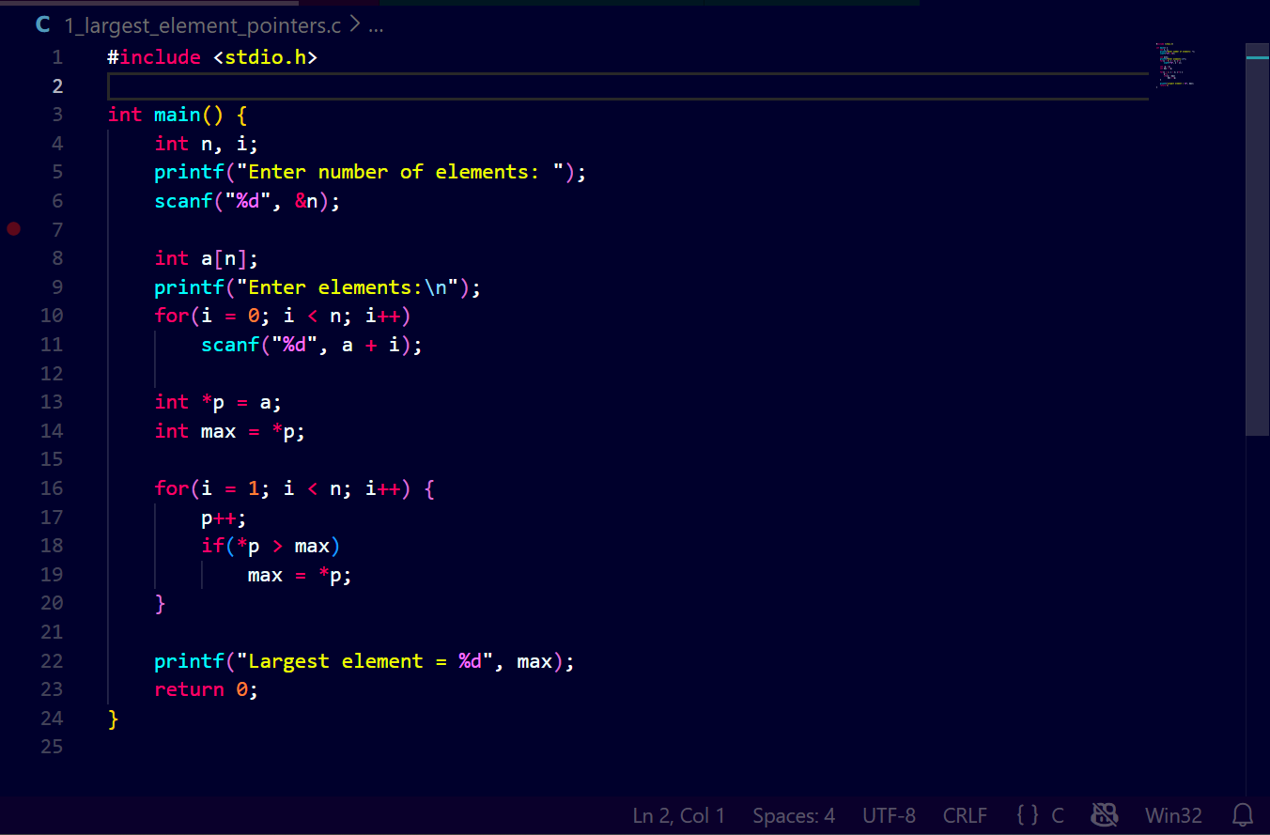Output

Program 2: Sum of Array Elements using Pointers
Aim
To write a C program to compute the sum of all elements in an array using pointers (without indexing).
Algorithm
- Read number of elements
- Read array elements
- Use a pointer to access each element
- Add values to sum
- Display the sum
Program Code
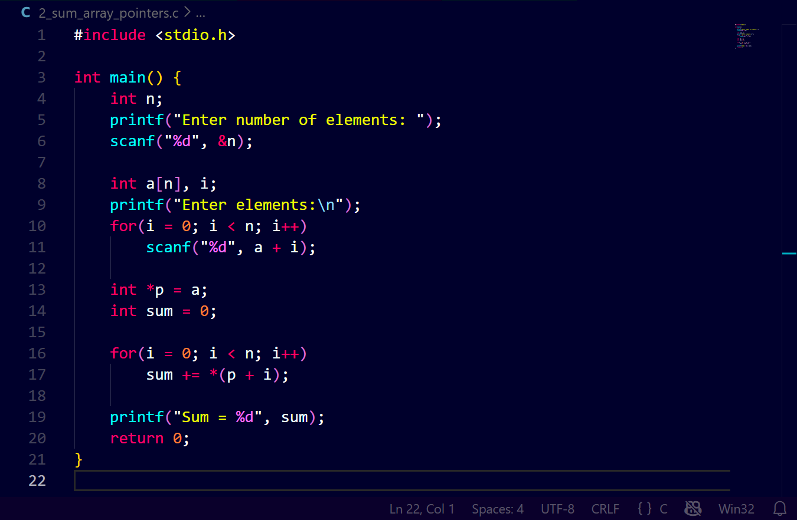Output

Program 3: Count Even and Odd Elements using Pointers
Aim
To write a C program to count how many elements in an array are even and odd using pointers.
Algorithm
- Read number of elements
- Read array elements
- Traverse array using pointer
- Check each value for even or odd
- Count and display results
Program Code
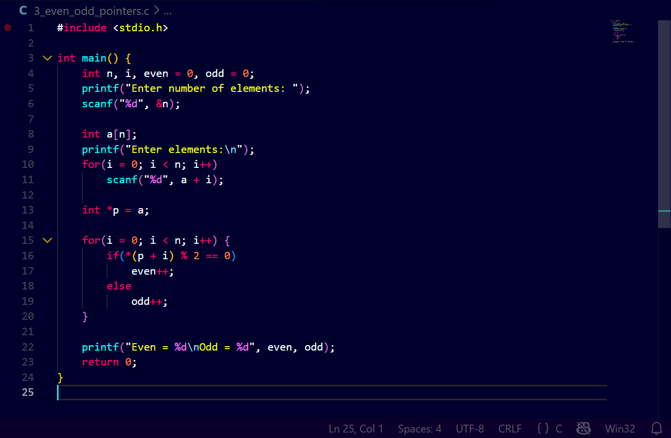Output
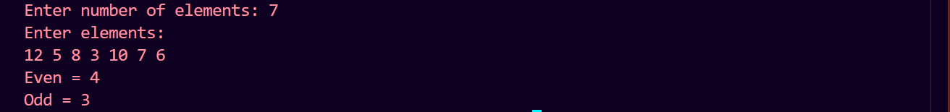

Program 4: Dynamic Memory Allocation and Average (malloc and free)
Aim
To write a C program to allocate memory dynamically for an array, read elements, and find the average using pointers.
Algorithm
- Read required size
- Allocate memory using malloc
- Read values through pointer
- Compute average
- Free allocated memory
Program Code
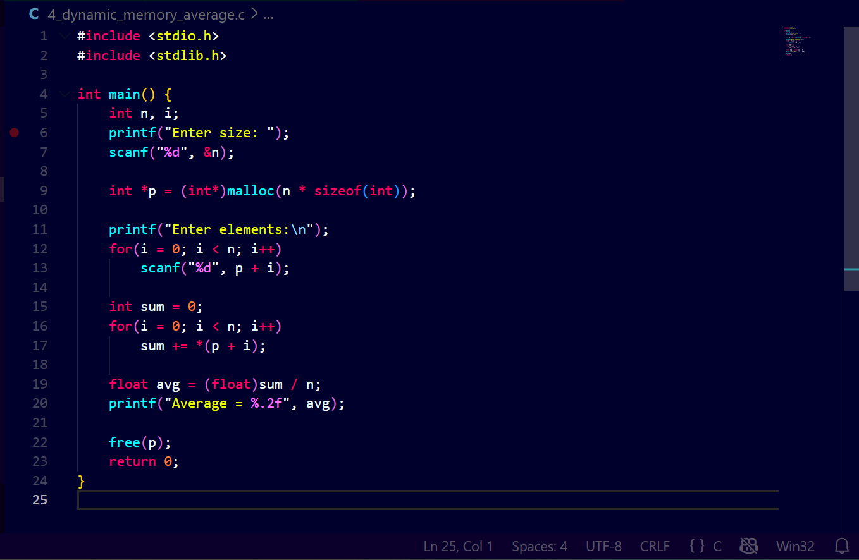Output

Program 5: Linear Search using Pointer Traversal
Aim
To write a C program to implement linear search using pointer traversal.
Algorithm
- Read number of elements
- Read array elements
- Read key element
- Traverse using pointer
- Display position if found
Program Code
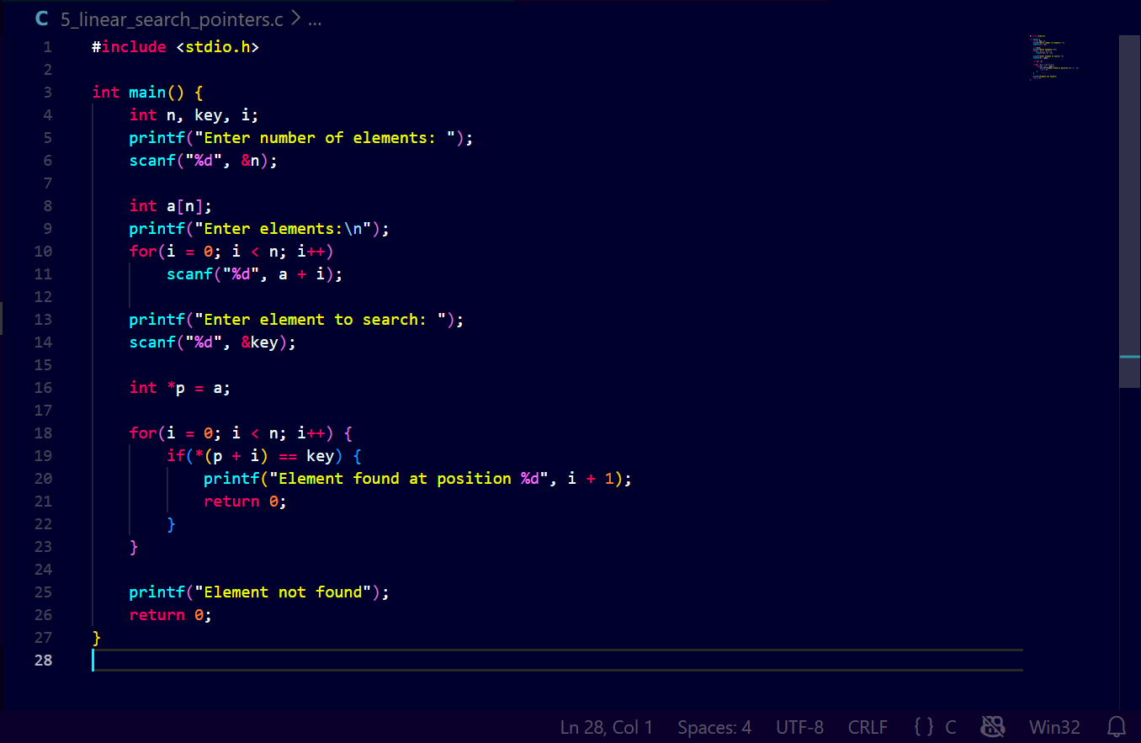Output
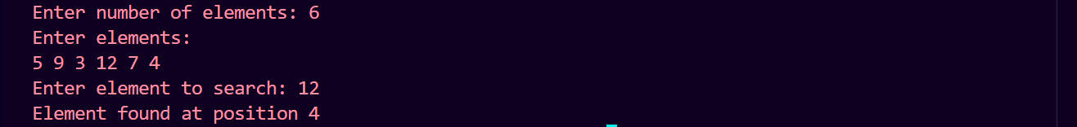

Program 6: Binary Search using Pointers (No Indexing)
Aim
To write a C program to implement binary search using pointers without array indexing.
Algorithm
- Read number of elements
- Read sorted array elements
- Use pointer arithmetic for mid, low, and high
- Compare key with middle element
- Display result
Program Code
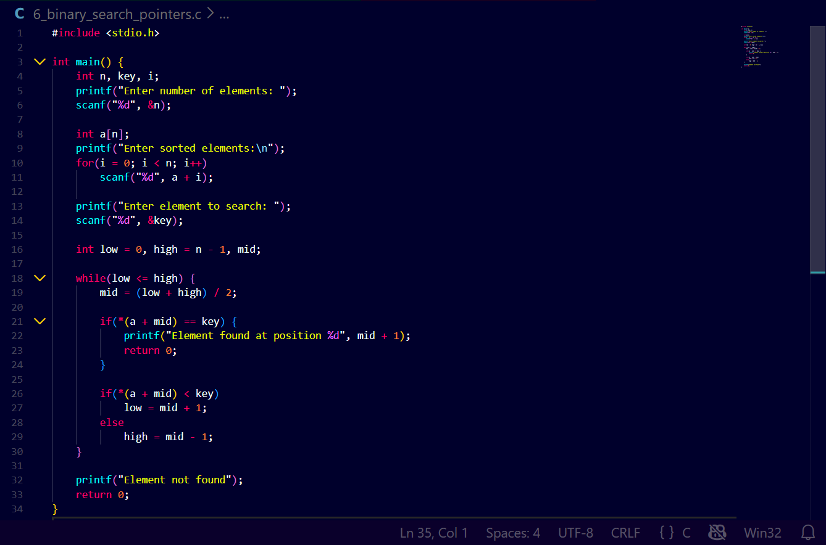Output
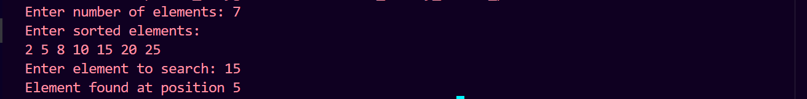

Program 7: Insertion Sort using Pointer Manipulation
Aim
To write a C program to implement insertion sort using pointer manipulation instead of array indexing.
Algorithm
- Read number of elements
- Read array elements
- Use pointer shifting for insertion
- Arrange elements in ascending order
- Display sorted array
Program Code
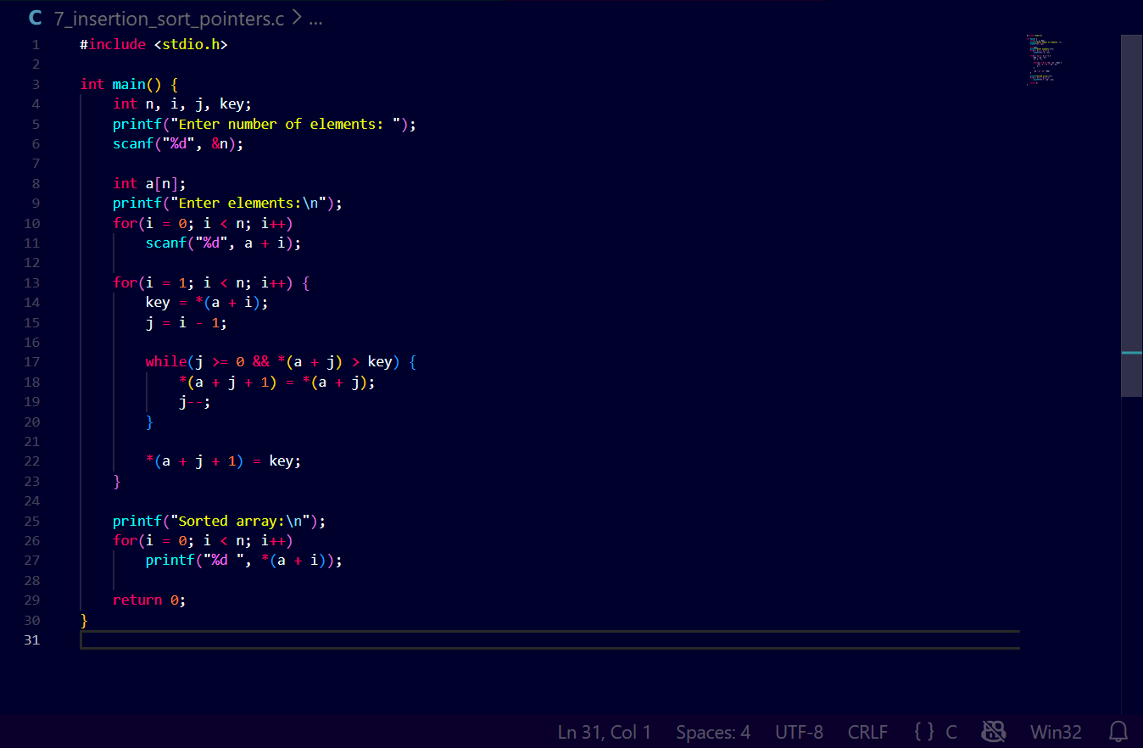Output
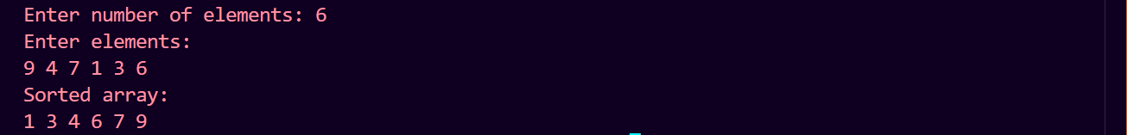

Program 8: Stack Implementation using Arrays and Pointers (PUSH, POP, PEEK)
Aim
To write a C program to implement a stack using arrays and pointers with push, pop, and peek operations.
Algorithm
- Initialize stack and top pointer
- Implement PUSH operation
- Implement POP operation
- Implement PEEK operation
- Display results
Program Code
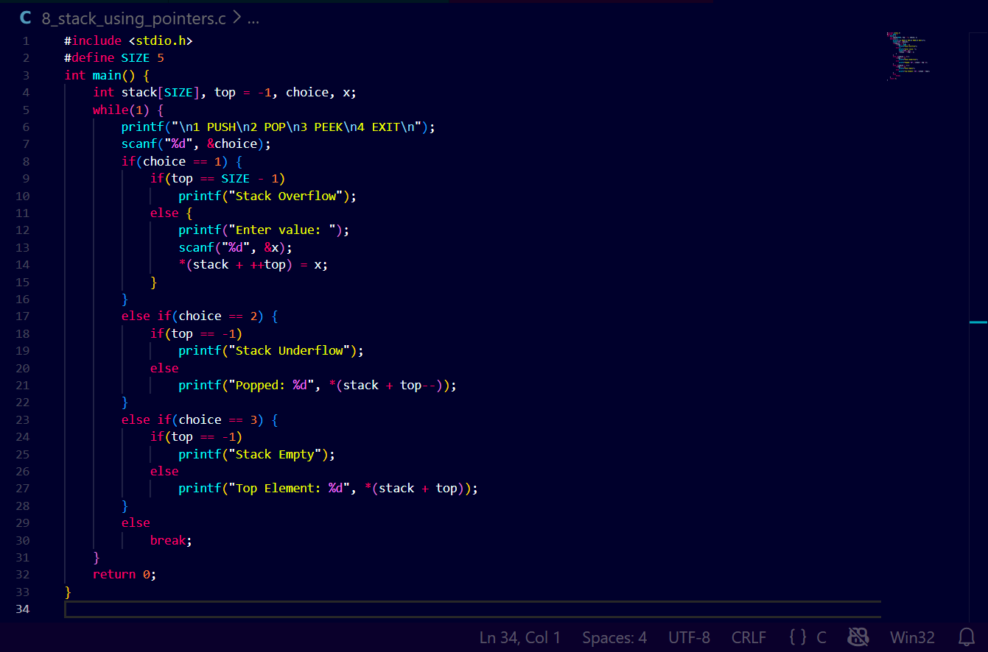
Output
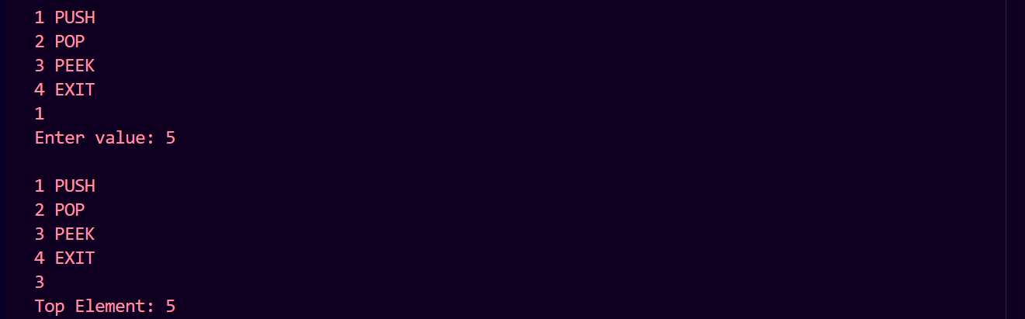

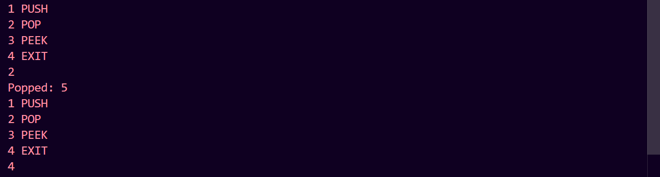

Result
All pointer-based programs and stack operations for Experiment 3 were successfully implemented, executed, and verified.

